

Physician Assistant Surgical Resident Handbook
2025 - 2026


Table of Contents
- Introduction
  - PA Residency Faculty
  - Program Overview
  - Physician Assistant Surgical
  - Residency Mission Statement
  - Department of Surgery Mission Statement
  - Physician Assistant Surgical Residency Vision
  - Department of Surgery Vision
  - Values

General Policies & Procedures
  - Prerequisites to Start the Surgical Year
  - Duty Hours
    - Eighty-Hour Work Week
    - Surgical Clinics
    - Resident Leave
    - Unplanned Absence
    - Interviewing
    - Fatigue and Resident Stress, Grievances, Substance Abuse Sexual Misconduct, Harassment, and Discrimination Policy
    - Pagers
    - Scholarships and Awards
  - On-Call
  - Record Keeping
    - CME Activities
    - Procedure/OR case log and Patient Care Encounters
  - Performance Evaluation of PA Surgical Residents
  - Rotation Schedule Changes

  - Resident’s Evaluation of Rotations and Attendings
  - Attire
  - Hospital Policies
    - Verbal Orders
    - Physician-Extender Orders

    - DEA number
  - Ordering Narcotics
  - Housing
  - Benefits
    - Health Insurance
    - Malpractice Insurance
  - List of Floors/Services
  - Conferences and Meetings
  - Online Training and Resources
    - CME Central Line Course
    - HIPAA
    - PACS Training
    - Protocols
    - SimSuite Online courses
    - Care Doc Training
    - Occupational & Environmental Safety Training
    - Ventricular Assist Device (LMS module)
  - OR Coding Services
  - Parking
  - Patient Confidentiality/HIPPA
  - Pyxis
  - Scrubs
  - Corrective Action
  - Withdrawal from the Program
  - Human Resources Policy Manual
  - Moonlighting
  - BLS and ACLS

- Program Closure

Introduction

Welcome to the Duke Physician Assistant Surgical Residency (PASR) Program and to Durham, North Carolina, the birthplace of the Physician Assistant (PA) profession. The PA profession originated at Duke in the mid-1960s. Dr. Eugene A. Stead, Jr., Chairman of the Department of Medicine at the time, believed that physician assistants could increase consumer access to health services by extending the time and skills of the physician. His vision, guidance, and influence were instrumental in founding the Duke PA Program which continues to flourish as one of the premier PA training programs in the country.

The PASR Program was started in 2002 as an extension of the vision of Dr. Stead and as the vision of Ted Pappas, MD, and Paul Hendrix, PA-C. The program was developed to train PAs in the surgical discipline while increasing access to care for hospitalized patients in the current hospital environment. The PASR Program demands a PA with the highest professionalism and motivation. This rigorous 13-month (12 clinical months + 1 didactic month) program will provide the PA with the knowledge, technical skills, and confidence needed to commence a fulfilling career as a surgical PA. The residents will be able to work side-by-side with renowned surgical attendings in an academic, tertiary care environment and care for the most complex of patients with rare disease processes and multiple comorbidities.

Medical Director:

The Duke PA Surgical Residency Program has a designated Medical Director, who assumes the supervising physician's responsibility for the PA surgical residents and maintains compliance with the rules and regulations of the North Carolina Medical Board. NC Medical Board: Physician Assistants

Additionally, the medical director reviews the didactic training, syllabi, presentation materials, clinical rotation schedule, and evaluation materials yearly to ensure that competent medical guidance is provided so that both didactic and supervised instruction meets current acceptable practice. The medical director presents selected topics to the PA surgical residents throughout their didactic training and evaluates their performance on didactic month and clinical rotations. The medical director reviews the PA surgical resident evaluations and procedure logs quarterly, duty hours monthly, meets with the residents monthly, and attends PA surgical residents’ meetings as needed.

The medical director also reviews alumni evaluations, interview applicants, and approves acceptance into the program. The medical director, along with the program director, maintains

the PA residency budget. The medical director reviews the application for accreditation and maintains compliance with standards. The medical director assures adequate resident progression, initiates remediation if needed, and assures the residents have met all requirements for graduation.

Program Director:
The program director (PD) is responsible for managing the PA surgical residency program and addressing any problems that arise. The PD coordinates the responsibilities of the PA program faculty and reports to the medical director any recurrent or serious issues or concerns regarding the PA surgical residents and functions of the program.

Didactic Training:
In conjunction with the assistant program director, the PD creates syllabi for the didactic month, schedules presentations, reviews the content of presentations and presents selected topics to the PA surgical residents. The PD evaluates the residents’ performances on their presentation, assesses participation, attendance, and reviews the PA surgical residents’ evaluation of their didactic training.

Clinical Rotations:
The PD works with the PD of the Department of General Surgery to ensure the clinical rotation schedule meets all program requirements, review monthly PA surgical resident evaluations, duty hours, procedure logs, and coordinate and attend PA resident meetings.

The requirements for the PA surgical residents, in no particular order, are as follows: 5 months in General Surgery
1 month in Thoracic Surgery
1 month in Neurosurgery
2 months of OR – (6 weeks since 2 weeks paid vacation can be taken at once or 1 week each month)
1 month in SICU (January or later) 1 elective month
1 month of nights

Evaluation:
The PD coordinates and leads quarterly evaluations, assures adequate resident progression, initiates remediation if needed, and assures the residents have met all requirements of graduation.

Alumni:
The PD completes letters of recommendation and credentialing paperwork for program alumni, sends out alumni evaluations, compiles results, and maintains active alumni contact information.

Recruiting/New Resident Selection:
The PD creates ads and pamphlets for advertising, reviews applications and selects for interviews, coordinates interviews, and in collaboration with the medical director, assistant program director, and the faculty selects applicants and notifies them of acceptance into the program.

Finances:
The PD works with the medical director and the Department of Surgery to maintain the PA residency budget.

Accreditation:
The PD is responsible for completing the application for ARC-PA accreditation and maintaining compliance with the standards with insight and collaboration with the medical director and assistant program director.

Management:
The PD coordinates the work of the assistance program director, program faculty, and program coordinator. The PD coordinates and attends the graduation dinner.

Assistant Program Director:
First and foremost, the assistant program director (APD) must function as an educator and advocate for the PA surgical residents. The APD serves as an advisor to the current residents and is in charge of the didactic month and coordinates lecturers for presenters for the practical sessions during the didactic month. APD works with the PD to design syllabi for the didactic month, schedule presentations, review the content of presentations, and present selected

topics to the PA surgical residents during the didactic phase and as needed throughout the year.
Administratively, the APD serves as a direct advisor to the PD. This includes the creation of the program accreditation application and continuous revision and maintenance of the document. Additionally, along with the PD, aids in the development of the didactic phase curriculum and continuous revision and improvement of the courses. This includes revising syllabi and providing course lectures throughout the didactic month. The APD is expected to attend and participate in all quarterly and final resident evaluation sessions and all administrative meetings pertaining to the PA surgical residency.

Program Coordinator:
The program coordinator performs the following duties:
- Process credentialing applications for the PA surgical residents by gathering the application, references, verifications, credentials, transcripts, and all supporting documents to obtain a complete file.
- Schedule interviews of the PA surgical resident applicants, secure conference rooms and interview rooms, and arrange breakfast, lunch, and refreshments as needed per program budget.
- Take minutes for meetings and send to all participants.
- Facilitate credentialing of all new PA surgical residents and set up in the Duke System so they can have access to various systems and areas within the hospital.
- Assist new PA surgical residents in obtaining their North Carolina PA license as well as their Intent to Practice forms with the North Carolina Medical Board.
- Obtain Duke Unique ID and NetID for new PA surgical residents.
- Assist the new PA surgical residents in obtaining ID badges, parking passes, lab coats, pagers, lockers, access to buildings, SEAL lab access, meal allowance, scrubs, and order prescription pads if needed.
- Assist in setting up orientation, didactic training, and securing conference rooms for lectures.
- Send out monthly evaluations of PA surgical residents and facilitate completion.
- Set up quarterly evaluation meetings between PA surgical residents and PD/medical director.
- Assist PD/APD in arrangements to attend the annual AAPA conference and other PA surgical residency-associated conferences.
- Organize graduation dinner and graduation certificates.

- Work with the Director of Education to keep expenses for the PA Surgical Residency Program within budget.

Program Faculty:
The PA surgical residency program faculty member attends curriculum meetings, applicant interviews, admission meetings, PA surgical resident meetings, journal clubs, and the graduation dinner. As faculty member, they provide education to the PA surgical residents in many ways including formal presentations during the didactic month and acting as mentors during clinical rotations. The faculty member is an advocate educator of the PA surgical residency program. Program faculty are expected to attend at least 75% of the meetings of the residency program.

Additionally, each faculty is assigned to serve as a mentor/advisor to one or more PA surgical residents. The duties include introducing themselves to the PA residents during the first week of the program and scheduling periodic meetings throughout the year. The faculty mentor/advisor is the first contact if a PA surgical resident has any concerns throughout the year and provides support as needed. The faculty member contacts the PD with issues or problems that require immediate attention or cannot be handled without assistance.

PA Surgical Residency Faculty and Staff
Kelli R. Brooks, MD Medical Director
Christina Steigerwald, PA-C Program Director
Emily Vernola, PA-C Assistant Program Director
Tracy Wilson, MHA Program Coordinator
Senthil Radhakrishnan, PA-C PASR Faculty/Advisor
Serena Kaylor, PA-C PASR Faculty/Advisor
Madeline Grobe, PA-C PASR Faculty/Advisor
Hailey Kessler Hourigan, PA-C PASR Faculty/Advisor
Erica Burdo, PA-C PASR Faculty/Advisor

Program Overview

This residency is not designed to produce technicians. The goal is to train competent physician assistants who provide a continuum of care for their patients. Emphasis is placed on preoperative and post-operative care with adequate importance to operative skills. As a PASR, you will serve as the primary contact when it comes to everyday patient care, be it completing history and physicals, ordering and interpreting appropriate labs and diagnostic tests, implementing a treatment plan, formulating a discharge plan, or responding to floor emergencies. However, you are never alone. It is a symbiotic relationship between you and the junior and senior residents, the chief residents, the attending surgeons, physician assistants, nurses, and social workers who help make a difference in your patients’ lives.

The required rotations in no particular order are:

2 Dedicated OR months (2 weeks of paid vacation is availed during this time) 1 SICU month
1 elective month
1 night month—we try to schedule this month in July/August --this would allow experienced providers to cover nights.
1 Neurosurgery month
5 General surgery months 1 Thoracic month

Continuing Medical Education

Throughout the 13 months of the residency, PA surgical residents will have access to more than 50 Category I CME through the various conferences provided by the Department of Surgery, specialty surgical departments, and divisions. The PA surgical resident is responsible to create an ETHOS account and enter the code provided at the beginning of the conference electronically on their smartphone. CME Records can be accessed online and printed as a PDF by visiting Duke Office of Continuing Medical Education

Department of Surgery Mission Statement and Vision
The Department of Surgery is committed to excellence, innovation, and leadership in meeting the healthcare needs of the people we serve, improving community health, and fostering the very best medical education and biomedical research.

As one of the leading national and international academic departments of surgery, we will assemble and integrate a comprehensive range of health care resources providing the very best in patient care, medical education, and clinical research. As the healthcare providers of choice in the region, we will improve the health of the communities we serve through the development of new, better models of healthcare. Through careful stewardship of our resources, we will preserve and promote our core missions of outstanding clinical care, discovery research, and improved health for these communities.

Physician Assistant Surgical Residency Mission Statement and Vision
The PA Surgical Residency Program is dedicated to innovation and the future of medicine by creating proficient and dedicated physician assistants capable of administering exceptional patient care.

As the birthplace of the Physician Assistant profession, we wish to remain at the forefront of PA education by providing licensed PAs with the knowledge and technical skills required to excel in the surgical subspecialties. This will improve surgical outcomes and patient satisfaction not only at Duke but also at academic and community hospitals throughout the Nation.

Department of Surgery Values

We earn the trust our patients place in us by involving them in their health care planning and treatment, and by exceeding their service expectations.

  - We maintain a work environment that nurtures respect for the individual within an atmosphere of cultural diversity.

  - We foster personal achievement and team accomplishments by encouraging honesty, commitment, and initiative.

  - We enhance the effective use of our resources through continual improvement of our performance.

  - We improve patient care and the ways in which it is delivered by supporting innovation and excellence in education and research.

  - We achieve new levels of success by partnering with individuals and organizations that share our vision.

  - We fulfill our societal responsibilities through our commitment to community citizenship.

II. General Policies & Procedures

Prerequisites to Beginning Surgical Year

  - Graduation from a PA Training Program approved by the Accreditation Review Commission on Education for the Physician Assistant (ARC-PA). A Master's degree is required, and applicants must have passed the National Commission on Certification of Physician Assistants (NCCPA) Certification Examination.

  - A credentialing file must be completed with Duke University Medical Center

  - Application process must be completed with the North Carolina Medical Board

Duty Hours

Eighty-Hour (80) Work Week

Providing PASRs with sound academic and clinical education must be carefully planned and balanced with concerns for patient safety and trainee wellbeing. Each program must ensure that the learning objectives of the program are not compromised by excessive reliance on trainees to fulfill service obligations. Didactic and clinical education must have priority in the allotment of trainees' time and energy. Duty hour assignments must recognize that faculty and trainees collectively have responsibility for the safety and welfare of patients and adherence to this policy. The institution is committed to the promotion of an educational environment, support of the physical and emotional well-being of its graduate medical trainees, and the facilitation of high-quality patient care.

The PASR program is integrated within the Department of Surgery's General Surgery Residency Program. As such, the PA Surgical Residents share the same call schedules, duty hours, and duty hour restrictions as the PGY- 1 MD intern staff. Great care is taken to make the schedule into 12-hour work shifts and attention is paid to keep the schedule to an 80-hour week averaged over 4 weeks (each rotation). Some rotations have 24-hour shifts but the 4-week schedule still averages to an 80-hour work week. Duty hours will be logged by each PASR. Logs will be reviewed monthly and reviewed with PASR during quarterly evaluations with PD. The PA surgical residents are expected and required to adhere to the scheduled shifts-singing on and signing off per the schedule. The PA surgical residents are required to report to the medical director and program director if they exceed their scheduled 12–hour work shifts and these work-hour restrictions.

    - Duty hours are defined as all clinical and academic activities related to the graduate medical education program, i.e., patient care (both inpatient and outpatient), administrative duties related to patient care, the provision for transfer of patient care, time spent in-house during call activities, and scheduled academic activities such as conferences. Duty hours do not include reading and preparation time spent away from the duty site.

    - Duty hours must be limited to 80 hours per week, averaged over a 4-week period, inclusive of all in-house call activities.

    - Trainees must be provided with one day in seven free from all educational and clinical responsibilities, averaged over a four-week period, inclusive of call. One day is defined as one continuous 24-hour period free from all clinical, educational, and administrative activities.

    - Adequate time for rest and personal activities must be provided. This should consist of at least 10 hours between shifts and must consist of at least 8 hours free of duty between all daily duty periods and after in-house calls.

Surgical Clinics

PASRs may attend the clinic while rotating on any of the General Surgery services when possible or when directed by the administrative chief resident. The PASR who is assigned to a specialty surgical service (i.e., Thoracic, Vascular, and Neurosurgery) may obtain outpatient clinic experience when possible or when directed by the MD/PA members of the specialty service.

Resident Leave

The Department of Surgery and the PA Surgical Residency Program leadership recognizes that unexpected circumstances may occur in the life of an individual PASR once the program has started. Please refer to the Duke Human Resources website which describes the various types of time away from Duke:

Time Away From Duke | Human Resources

A meeting with the Medical Director is mandatory, in the event that a PA resident believes that conditions exist to request leave from the program for any of the following circumstances listed on the Duke HR website: bereavement leave, jury duty, parent involvement in school, family medical leave, personal leave of absence, etc. The Duke PA Surgical Residency Program requires that the PASR completes forty-eight (48) weeks of clinical activity for successful completion of the program. Any PASR unable to complete the required forty-eight (48) weeks of clinical activity will have to reapply during the next scheduled session of candidate interviews to be considered for re-entry into the program. Note, this is based upon the 13-month format of the program.

Unplanned Absence or Tardiness

If a resident is unable to make it to work or will be late, it is the PASR’s responsibility to notify the program director and the chief resident of their service prior to the beginning of the scheduled shift. The information must be relayed via direct conversation. Emails, text pages, or voice messages on home phones or cell phones are not acceptable. Each unplanned absence or event of tardiness will be reviewed by the program director. The event will be discussed with the individual PASR involved. PASR unplanned absences or tardiness may result in Corrective Action (refer to p.20 U.).

Interviewing

As graduation nears, it may be necessary for the PASR to interview for positions outside of Duke. It is the responsibility of the PASR to plan ahead for the scheduled interview. This planning will involve discussion with the chief resident or the administrative chief on their service as well as direct conversation with the program director to ensure that appropriate coverage is available for the service during the time that the PASR will be away.

Personal

Fatigue and Resident Stress

This policy is to assist the Department of Surgery in its support of high-quality education and safe/effective patient care. The Department of Surgery is committed to meeting the requirements of patient safety and PASR well-being. Excessive sleep loss, fatigue, and resident stress are serious matters. In the event that any resident experiences fatigue and/or stress that is interfering with his/her ability to safely perform his/her duties, they are strongly encouraged and obligated to report this to his/her senior resident and/or supervising attending on service.

Appropriate backup support will be provided when patient care responsibilities are especially difficult and prolonged, and if unexpected needs create resident fatigue sufficient to jeopardize patient care during or following on-call periods.

All attendings and residents are instructed to closely observe other residents for any signs of undue stress and/or fatigue. Faculty and other residents are to report such concerns of sleepiness, tardiness, resident absences, inattentiveness, or other indicators of possible fatigue and/or excessive stress to the supervising Attending and/or medical director. The resident will be relieved of his/her duties until the effects of fatigue and/or stress are no longer present.

Additionally, all PASRs have access to the Duke Personal Assistance Service (PAS) program. The PAS provides professional counseling to Duke Faculty and staff, and their immediate family members while maintaining confidentiality. The services of the PAS are free of charge, and the office can be reached at 416-1727. More information is available on the PAS website.

Personal Assistance Service | Duke

Grievances:

The PA residents are eligible for the Dispute Resolution Process policy as a method to adjudicate a grievance.

Dispute Resolution Process | Human Resources (duke.edu)

Substance Abuse:

Policies describing how PA surgical resident’s impairment, including that due to substance abuse, will be handled by Duke HR policies and guidelines.

Substance Abuse | Human Resources (duke.edu)

Sexual Misconduct, Harassment and Discrimination Policy

To promote a respectful and productive work environment, harassment of any kind is not acceptable at Duke. Refer to Duke HR policies.

Sexual Misconduct | Human Resources (duke.edu) Harassment & Discrimination | Human Resources (duke.edu)

Pager Functions

Pagers are issued to each PASR. The PASR is to promptly contact the Program Coordinator should there be any concern regarding pager malfunction. The Duke paging system has the capability to change the functional status of the pager. To enhance team communication and to coordinate patient care, each PASR will have the pager status assigned to #2 “On-Page” while the PASR is scheduled to be in the hospital providing patient care. The pager status may be switched to #8 “In surgery” as appropriate. To achieve adequate intervals of rest (page 6. B. d.) and to avoid fatigue and resident stress (page 8 B. 6.) the PASR is to change the pager status to #5 “Active Covering ID” whenever the PASR is scheduled to be away from the hospital. The PASR is to enter the covering pager number for the in-house team functional pager for the clinical service to which the PASR is assigned during the interval time when the PASR is scheduled to be away from the hospital. At no time during the program is a PASR’s pager status to be changed to: “Not on page”. All PASR pager security codes are to be the last four digits of the assigned pager number. If your personal pager has a password and the last four digits of the pager number are not the correct password, it may be your Duke Unique ID.

Scholarships and Awards

The program director encourages the PASRs to pursue scholarships and awards designated for physician assistants in postgraduate training programs. However, due to resident work hour restrictions and the rigorous clinical schedule of the PASR staff, there is no guarantee that additional vacation or leave time will be granted by the

Program if a PASR is requested to travel to a meeting for the presentation of a scholarship or award to a member of the PASR staff.

On-Call

  - The objective of on-call activities is to provide residents with continuity of patient care experiences throughout a 16-hour period. In-house call is defined as those duty hours beyond the normal workday when trainees are required to be immediately available in the assigned institution.

  - In-house call must occur no more frequently than every third night, averaged over a four-week period.

  - Continuous on-site duty, including in-house call, must not exceed 24 consecutive hours.

  - When trainees are called into the hospital from home, only the hours trainees spend in-house are counted toward the 80-hour limit.

Record Keeping

PASRs are required to log their CME Activities and procedures/OR cases at https://ja.dh.duke.edu/ and PA Surgery Residency | General | Microsoft Teams respectively. Compliance with this policy is mandatory. Failure to comply will result in disciplinary action.

  - CME: Throughout the 13 months of the residency PA surgical residents will have access to more than 50 Category I CME through the various conferences provided by the Department of Surgery, specialty surgical departments, and divisions. The PA surgical resident is responsible to create an ETHOS account and enter the code provided at the beginning of the conference electronically on their smartphone. This will be reviewed by the program director on a quarterly basis to ensure compliance.

  - Procedure/OR case log: PASRs are required to keep an accurate and up-to-date log of all procedures and OR cases. This will be reviewed by the program director on a quarterly basis to ensure compliance.

Performance Evaluation of PA Surgical Residents

At the end of each rotation, attending surgeons, chief residents, senior residents, and physician assistants of their choice will evaluate the PASRs. The PASRs will be required to submit their names, via email, to the program coordinator at the end of each rotation. The evaluations of the PASR clinical performance will be conducted electronically through Qualtrics or Microsoft Forms.

Rotation Schedule Changes

PASRs are scheduled to rotate through the various specialties and sub-specialties to enrich their surgical experience. Every effort will be made to accommodate a PASR request for one of their last three clinical rotations. Any concerns, conflicts, or changes should be brought to the attention of the program director. Due to resident staffing issues, rotation schedules may have to be modified throughout the year at the discretion of the program director of the PA Surgical Residency Program and the program director of the MD surgery residency program.

Resident’s Evaluation of Rotations

Upon completion of each rotation, PASRs are required to complete an evaluation of the service. The Qualtrics or Microsoft Forms link will be distributed to the PASR by the program coordinator. A 6-point Likert scale will be used to evaluate the clinical experience, completion of rotation objectives, team atmosphere, and overall effectiveness of the rotation being evaluated.

Attire

The purpose of the dress code is to enhance a patient’s confidence in the employees, faculty, and residents of the Department of Surgery as highly competent members of a healthcare team who are strongly committed to quality service. The PASR staff will wear provided scrubs while in the OR otherwise, the program requires the PASR staff to wear professional business attire in the clinics and while walking to and from the parking deck.

Wearing the provided OR scrubs outside of the hospital is strictly prohibited and if wearing OR scrubs in-house, a white coat must be worn over them.

Hospital Policies
  - Verbal Orders
    - Verbal orders should be used only to meet the care needs of the patient when the ordering practitioner is unable to enter the order himself/herself because he/she is not physically able to access the medical record or EPIC.
    - A nurse is in communication with a PASR by telephone or in other circumstances in which a pin-station /EPIC is not accessible to the PASR. The PASR orally gives specific orders for a specific patient to be carried out before the PASR cosigns the orders. The nurse confirms that the order was heard correctly by immediately repeating the name of the patient and the order back to the PASR (except during a Code 5) using a 'read back' system of communication. The 'read back' system is where the nurse enters the order as heard and reads back to the PASR the order as entered. For sound-alike medications, the name is spelled back to the PASR. The PASR then verifies the accuracy of the read-back order. The nurse writes the orders and next to them the notation, "V.O. [verbal order] for PASR XXXX." Under this, the nurse signs his/her own name, title, and the orders are then carried out. For the purpose of interpretation, the PASR functions as an agent of the supervising physician or backup supervising physician.
    - Verbal orders must be cosigned by the prescribing practitioner as soon as possible and reflective of the earlier of the following: The next time the prescribing practitioner provides care to the patient, assesses the patient, or documents information in the patient’s medical record, or within 48 hours of when the order was given. The signature must be dated and timed. If the prescribing practitioner is not available to authenticate the verbal order, a covering physician may cosign the order. The signature indicates that the covering physician assumes responsibility for the order as being complete, accurate, and final. A physician assistant or nurse practitioner may not authenticate a verbal order given by a physician. In this procedure, the nurse serves only as a scribe for the physician. This procedure may not be used unless the physician specifies the name of the patient and the full and exact content of the order written. The physician will state the order directly to the writer, not indirectly through another nonphysician intermediary.
    - Verbal orders may not be given for:
      - Cancer chemotherapeutic agents
      - Investigational drugs

      - Systemic thrombolytic agents. NOTE: Verbal orders may be given for alteplase (tPA) for the purpose of declotting a catheter.
      - Initial dose of insulin.
    - Verbal orders are limited to the attending physician for limiting cardiopulmonary resuscitation as witnessed by another physician and a registered nurse. (See Doctor's Orders to Limit Cardiopulmonary Resuscitation [DNR] Procedure for details.)

DEA Number

All prescriptions written in North Carolina require the prescriber’s Drug Enforcement Administration (DEA) number. The PASR is responsible for obtaining their DEA.

Ordering Narcotics

The PASR is only allowed to prescribe a legitimate supply of a controlled substance in accordance with NC Physician Assistant Regulation 21 NCAC 32S .0212 21 NCAC 32S .0212 PRESCRIPTIVE AUTHORITY
Prescriptions for Narcotics should adhere to NC Stop Act of 2017 Understanding NC Stop Act
Note: Some out-of-state pharmacies may not honor prescriptions of narcotics by a PA. Many of our patients are from surrounding states so be mindful of this while discharging them. Call the out-of-state pharmacy to verify or talk to the patient about filling the prescription at an in-state pharmacy.

Housing

The PASR will be responsible for securing housing.

Benefits
  - Health Insurance

In October, once officially hired, open enrollment is 30 days from the hire date. PASR should log on to Duke@Work and enroll in the health insurance options for individual and family members of choice. Duke HR self-service Duke@Work.

In addition, information regarding Reimbursement Accounts, Disability Benefits, Life Insurance, Retirement Savings Programs, Live for Life Program, Long Term Care Insurance, Personal Assistance Service, and Personal Casualty Insurance can be obtained from the Duke Human Resources website. Benefits: Duke HR

Malpractice Insurance

PASRs are covered by Durham Casualty Insurance, which covers all of Duke’s providers. If you would like additional information, contact Duke Risk Management at (919) 684 – 6226.

List of Floors/Services

Duke North:
Second floor: 2200- ER obs unit
Third Floor: Thoracic surgery
4th floor: gen med
5th: neonatal, peds, OB
6th: PSU/ENT/Urology/ GYN Onc, 6100- CTS
7th: cardiology
8300/8100 GSU
9th: 9300- oncology, 9100 gen med

DCT:
1- peds surg/ Starbucks
2- pediatrics/ PICU
3- pediatric cardiac/ peds CICU
4- peds oncology
6- Transplant/ GSU
7- Neuro ICU
8- Neuro- step down
9- Neuro/ spine stepdown
10- adult blood/ marrow transplant
11 ortho/ trauma

DMP
1- panera/ gift shop, radiology
2- conference rooms
3- OR/ PACU
6- 6W- SICU, 6E- CT Stepdown
7 - 7W- CTICU, 7E- CICU
8- 8w- MICU, 8E- Gen med stepdown

Conferences

  - General Surgery Resident Case Conference
PASRs are required to attend weekly Case Conference.

  - General Surgery Grand Rounds
PASRs are required to attend weekly Grand Rounds

  - PASR Meeting
PASRs are required to attend a monthly and Quarterly resident meeting with the Medical Director and Program Director. This could be both informal during rounds and a more formal meeting. PASRs should attend the monthly journal club hosted by the PA program faculty and must come prepared by reading the assigned articles. PASRs are encouraged to meet with Program PA Advisors/Mentors as needed.

  - Surgical Subspecialty Conferences
The PASR is encouraged to attend the weekly conference for the current clinical rotation to which the PASR is assigned. Examples of these conferences include the following:

    - Thoracic Surgery on Wednesday mornings
    - Vascular Surgery on Friday mornings
    - General Thoracic Surgery on Thursday mornings
    - Hepatobiliary/GI Surgery on Tuesday mornings
    - Trauma Surgery on Thursday mornings
    - Critical Care on Thursday @ 12 Noon
    - Neurosurgery on Wednesday mornings
Morning report daily at 0600 and 0500 on Wednesday, while on general surgery services is mandatory.

Online Training and Resources – unless otherwise indicated, all online training is required to be completed during the Didactic Month prior to beginning clinical rotations.

  - Insertion of Central Venous Catheter Course Click here for CVC Training
https://dicontraining.medicine.duke.edu/catalog
Select: Register for New Account Institution: Duke University Hospital
Access Code: dicon

Select: Course Index
Select: Insertion of Central Venous Catheter Course
Print the certificate of completion and give a copy to the program coordinator
Contact the website to get access to this training

  - HIPAA
Refer to section seven for instructions to log into the Occupational & Environmental Safety website to complete online HIPPA education.

  - Occupational & Environmental Safety Training
Click here to complete all required Hospital safety courses. http://www.safety.duke.edu/
Select the Online Training tab in the left column. Sign in with your Net ID and Password. Complete all Required Training modules listed below. Print certificates of completion and give a copy to the program coordinator.
Hospital Requirement Modules:
- OSHA Bloodborne Pathogens
- TB Safety Training
- Fire/Life Safety
- General Chemical Safety
- Surgical Care Improvement Project
- HIPAA Privacy and Security Training
- Infection Control
- Hand Hygiene
- Equity at Duke
- Environment of Care
- Compliance Update Training
Program Required LMS Modules:
(12) Cultural Competence: Building Cultural Awareness, Competence and Humility

(13) Understanding Human Difference: Implicit Bias, Inclusion and Belonging

(14) Collecting Sexual Orientation and Gender Identity Information on Our Patients

(15) Introduction to Quality Improvement
(16) Introduction to Quality Improvement Methods

Introduction to Patient Safety and Quality Improvement
(17) ‘Duke Diversity & Inclusion Learning Module’ (0081277)

  - Ventricular Assist Device (VAD) online education modules
VAD education modules are to be completed before beginning a clinical rotation on the Thoracic Surgery (TSU) service. Complete the LMS module: Ventricular Assist Device - Level 2 Education (00152112)

Coding Services

The PASR should become familiar with the coding offices and the proper way to report those services for which reimbursement can be applied.

Office Locations and contacts are as follows:

Felice McNair, CPC (PDC Compliance) mcnai002@mc.duke.edu 668-5165

Duke North ORs
Kevin Rathman, CPC Debbie Ryan, CPC
3415 Duke North 3415 Duke North
681-3290 681-3226

Ambulatory Surgery Center Ella King, CPC
2122 Ambulatory Surgical Center 668-2019

Parking

The PASR will be issued a parking permit. The program coordinator will distribute these on your first day. If you have any problems with lot access, contact:

Parking and Transportation Services Phone: (919) 684-7275
Hours: Monday-Friday 7:30am-5:00pm Online: http://www.parking.duke.edu/
If you are assigned PG II garage across the street there is a tunnel in the hospital that connects the garage. The other garage can be accessed through the Duke Eye Center.

Patient Confidentiality/HIPAA

PASRs are required to follow all HIPAA guidelines as per their HIPAA and Security Online Training.

Pyxis

This is the unit that holds all the medical supplies needed on the floor (i.e. Gauze, tape, staple removers, needles, etc.) Every floor has a Pyxis, some floors have more than one. PASRs will receive training and a password to access it.

Scrubs

Duke University Medical Center will provide scrubs to PASRs. Your ID badge will be credited with three pairs of scrubs. Once the three pairs are checked out, they must be returned to gain credit toward a clean pair. Please see Attire (Page
15. H.)

Corrective Action

If a PASR consistently performs below expectations as evidenced by poor performance on evaluation(s), verbal complaints by faculty or staff, or violations of items as set forth in the PASR Handbook a written warning will be issued, and a meeting will be held with the PASR to discuss the issue. This PASR coaching session will be used to formulate a plan for the PASR to correct the issue. If the PASR’s performance does not improve, further disciplinary action may then be pursued on an individual basis. Disciplinary action may result in probation with required remediation and/or termination of employment. PASR insubordination may also result in termination of employment. For more information, please refer to:
Duke HR Staff Handbook

Withdrawal from the Program

The PASR has the option to withdraw from the residency at any time without cause and for any or no reason and be excused from further obligation or liability provided that any such termination shall be upon at least thirty (30) days prior written notification (the “Notification Period”). Failure by the PASR to give at

least thirty days’ notification will result in an unquantifiable hardship on the Hospital and will be remedied by the PASR’s payment to the Hospital of liquidated damages equal to fifty percent (50%) of the PASR’s monthly compensation at the time of the PASR’s withdrawal.

Human Resources Policy Manual

For comprehensive details about Duke’s Human Resources policies, procedures, and forms, please visit the HR website at:

http://www.hr.duke.edu/policies/index.php

Moonlighting

PASRs are permitted to moonlight 12-hour shifts within the Duke University Medical Center surgical services during the residency program on their day off provided they have a 12-hour break before starting their scheduled work. They cannot, however, moonlight outside the Duke University Medical Center and or outside the surgical services they rotate through.
.

BLS and ACLS certifications

Current BLS and ACLS certifications must be maintained at all times throughout the duration of the program. Copies of current BLS and ACLS certificates are to be provided to the program coordinator.

III. Program Closure

In the unlikely event that the PASR program must be closed prior to the planned graduation of the program’s current PASR staff, the Duke University Medical Center Surgical Physician Assistant Residency Program will make a reasonable effort to complete the training of residents actively enrolled in its training program. If this is unable to be achieved, then the program will pursue the possibility of placing the affected PASRs in another post-graduate surgical PA training program or assist PASRs in finding employment.

Before making any reduction in the number of PASR positions, the medical director will work with the Department of Surgery to ensure that careful consideration has been given to the impact that such a reduction would have upon the department’s other residency training programs. Duke Hospital will also evaluate the impact on the quality and safety of care being provided to the patients. PASRs will be informed as soon as possible of any decision regarding program closure or reduction in program size.

Tips/FAQ’s

A. What to do before you arrive at Duke

- Secure housing

- Appointment with Employee Health and Wellness Duke South Clinic
Basement/Ground Red Zone/PRT Level 684-3136
(Your immunization record is required)

- Lab Coats
The Program Coordinator will provide instructions to the incoming PASR staff to obtain their lab coats prior to beginning direct patient care responsibilities on clinical rotations.

The Duke University Medical Center Bookstore Duke South Clinics Room 0001 (near food court) Durham, NC 27708
Phone: (919) 684-2717
Hours: Monday-Friday 8:30am-5: 30pm Saturday 10:00am-4:00pm Sunday Closed
Online: http://www.dukestores.duke.edu/medical.php

- Apply for your North Carolina Medical License. (**Important** This may be daunting and most time-consuming, and an early start is warranted. Please take the PANCE exam as soon as you graduate and start the application for licensure immediately as it may take up to three months after the license materials are received. You will need three letters of reference. You will also need three letters for credentialing at DUMC. Have your letters of reference include references to both the hospitals and for your license, so you will not have to get six different letters.) Follow up with the medical board frequently to ensure that all of your application materials have been received and are complete (Especially fingerprints).

PA application available on NCMB website: http://www.ncmedboard.org/licensing/license_application/category/ph y sician_assistants_with_fcvs/

- Complete Duke credentialing – the Credentialing Verification Office will process all applications for clinical privileges.

Credentialing Verification Office Phone: 919-684-4022
Fax: 919-684-8912

Diversity and Inclusion, Cultural Competence, Implicit Bias, Sexual Orientation

Duke Surgery has a Section on Diversity and Inclusion with a primary focus on Education to cultivate a new culture within Duke Surgery through education and training that recognizes implicit and explicit bias and facilitates inclusivity among surgeons and the staff/trainees. The goal is to promote diversity and inclusion in the workplace and provide formalized training shared by all members of the division in the following:
Cultural Complications Curriculum Seminar Series
Grand Rounds Speaker Guidelines Medical Student Curriculum Civility Champions
Mentorship Recruitment
Leadership and Structure Hiring and Promotion Community Outreach Macro-Microaggressions
Additional information can be found at: https://surgery.duke.edu/about- department/seeds/resources

Earlier in 2021, as part of Duke’s larger commitment to stand up for our values of diversity and inclusion, to be more self-aware, and to make equitable choices daily, Duke University Health System (DUHS) introduced a new bundle of virtual diversity and inclusion training. Compliance and understanding will be verified by a quiz requiring a passing score at the end of the LMS modules:
- The ‘Cultural Competence: Building Cultural Awareness, Competence, and Humility’ (00152494) course is to help the learner develop an awareness and understanding of the journey of acknowledging and accepting human difference throughout our life journey. This course further assists with creating an environment of inclusion and belonging where we all are welcomed, valued, and meeting our core value of ‘caring for our patients, their loved ones, and each other.’
- The ‘Understanding Human Difference: Implicit Bias, Inclusion and Belonging’ (00152495) course is to help the learner develop an awareness and understanding of how we are all wired, as human beings, to have implicit bias. Once we recognize our bias, we are better able to exhibit behaviors to accept human differences to create an environment of inclusion and belonging where we all are welcomed, valued, and
meeting our core value of ‘caring for our patients, their loved ones, and each other.’

- The ‘Collecting Sexual Orientation and Gender Identity Information on our Patients’ (00152493) course is intended for clinical or non-clinical staff and will enable participants to: 1. Explain LGBTQ+ terminology and demographics 2. Describe health disparities in LGBTQ+ populations 3. Apply best practices in serving LGBTQ+ patients
- The ‘Duke Diversity & Inclusion Learning Module’ (0081277) course covers workplace equity, cultural awareness, and creating inclusive environments for both patients and staff.

PA surgical residents must participate in monthly morbidity and mortality conferences with specific content series on the Cultural Complications Curriculum. Additionally, participate in Unconscious Bias Dialogues. Through a series of group discussions and presentations, residents are educated on the definition of unconscious bias. They then confront their own implicit biases toward others.
Continued peer-to-peer conversations are provided in a safe place to have open dialogue and reflection while engaging with a guest on a specific topic and the care of patients throughout the year. Duke Surgery community check-in series is also available to PA surgical residents and members of Duke Surgery to discuss pandemic, racial injustice, and unconscious bias subjects.

Monthly PA surgical residents’ journal clubs are held. These include specific group discussions analyzing all articles for any implicit bias in facing underserved patient populations when applying that article's data and results.

Performance and Quality Improvement to Improve Healthcare Outcomes.

Addressed in the didactic month. PA Surgical Residents must complete the Duke Learning Management System (LMS) Modules:

Introduction to Quality Improvement (00123329) Duration: 00:40
This online module provides interactive content to instruct clinicians in applying Quality Improvement processes within their practice. Nationally recognized models are presented in context with analysis and application of key components. Case studies are included for practical application of stages and tools. Upon completion of the module, participants will be able to:
- Define quality improvement (QI)
- Identify differences between quality improvement and research design
- Describe elements in the IHI Model for Improvement
- Create a SMART aim statement
- Define measures
- Use a modified FMEA to understand a process
- Construct a PDSA cycle
- Analyze a run chart and
- Identify QI resources/toolkits.

Introduction to Quality Improvement Methods (00136910) Duration: 00:25
This training module provides a clinician learner with a solid foundation and tools to design and implement a quality improvement project using the IHI Model for Improvement and iterative PDSA cycles. The learner will gain an awareness of the need for quality improvement in healthcare and be able to uncover an issue to address, assemble a team of stakeholders, create a “SMART” Aim, establish appropriate metrics for determining measurable improvement, design tests of change, and evaluate and iterate on the effect of the interventions. Following the completion of this module, the learner will be able to
- pursue high-value quality improvement in their practice

Introduction to Patient Safety and Quality Improvement (00106987) Duration: 00:20
These eLearning modules with provide GME trainees with a basic understanding of the fundamentals for patient safety, quality improvement methodologies, the rationale for practicing high-value care, and methods to practice high-value care.
Objectives:
  - Review the origins of the modern patient safety movement
  - Describe different "safety events" a clinician may encounter
  - Understand how to create and foster a "Just Culture" in the clinical environment
  - Examine the tools needed for systematic reviews
  - Connect patient safety to quality improvement • Explore proper safety reporting

Principles and Practice of Medical Ethics
In addition to medical ethics being addressed on an ongoing basis during grand rounds with relevant patients and situations throughout the year, the PA Surgical Residents, during their didactic month, will have a Lecture on Medical Ethics delivered by a faculty from Palliative Care or Trent Center for Bioethics, Humanities & History of Medicine to address the following objectives:
- Understand the principles of medical ethics: beneficence, non-maleficence, justice, autonomy
- Understand Informed Consent
- Understand Goals of Care Discussion
- Understand End-of-Life Decision Making
- Understand Withdrawal of Care
- Understand Healthcare Power of Attorney
- Recognizing common ethical concerns in the medical/surgical setting
- Recognizing steps to take before calling an ethics consult
- Understand when it is appropriate to call Duke’s Ethics Consult
In addition, Duke PA Surgical Residents have access to many optional recorded lectures of the past and future available online at Duke University’s Trent Center for Bioethics, Humanities & History of Medicine - The Boyarsky Lectureship in Law, Medicine and Bioethics, The Nancy Weaver Emerson Lectureship in Medical Ethics, The McGovern Award Lectureship. Anyone interested in gaining more knowledge/understanding can access the Trent Center website. Here are some we recommend to our PA Surgical Residents:
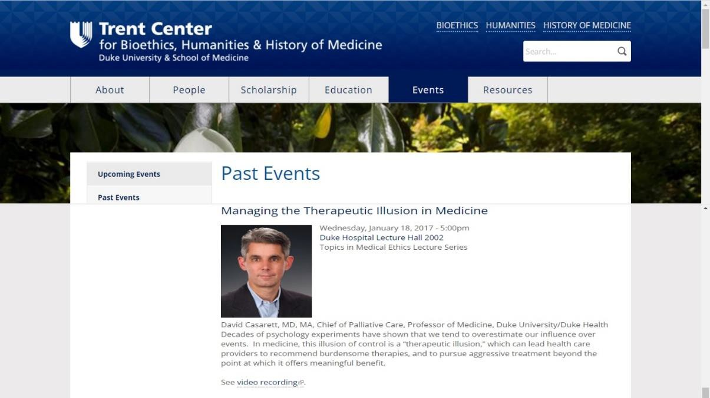

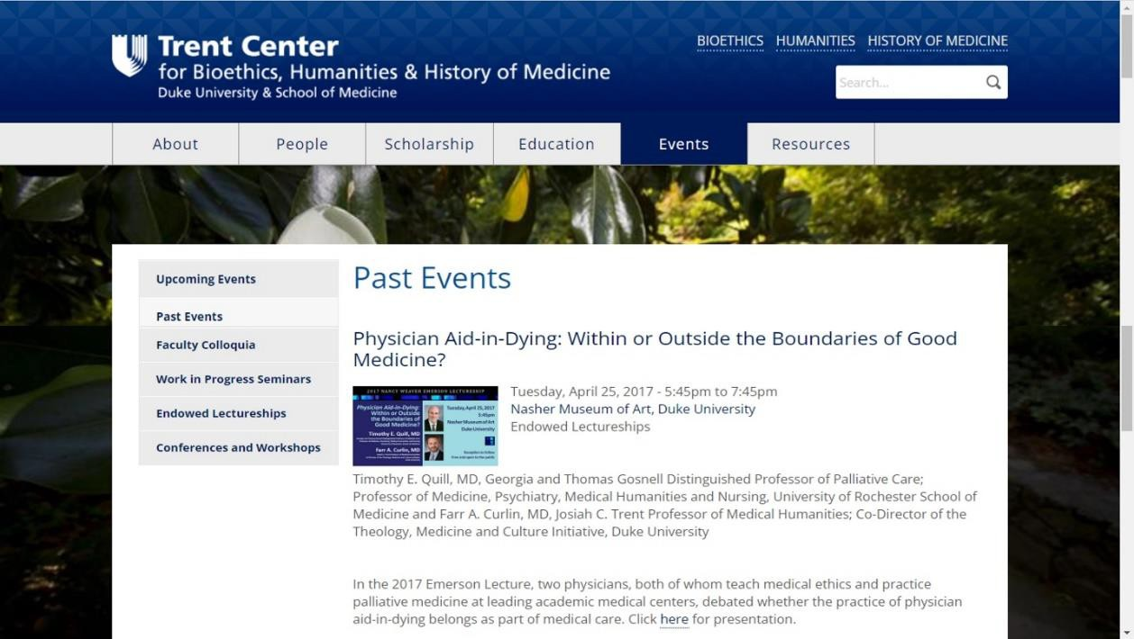

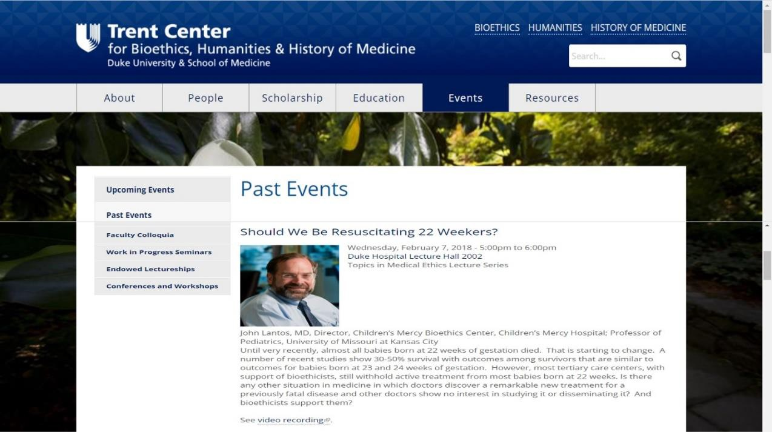

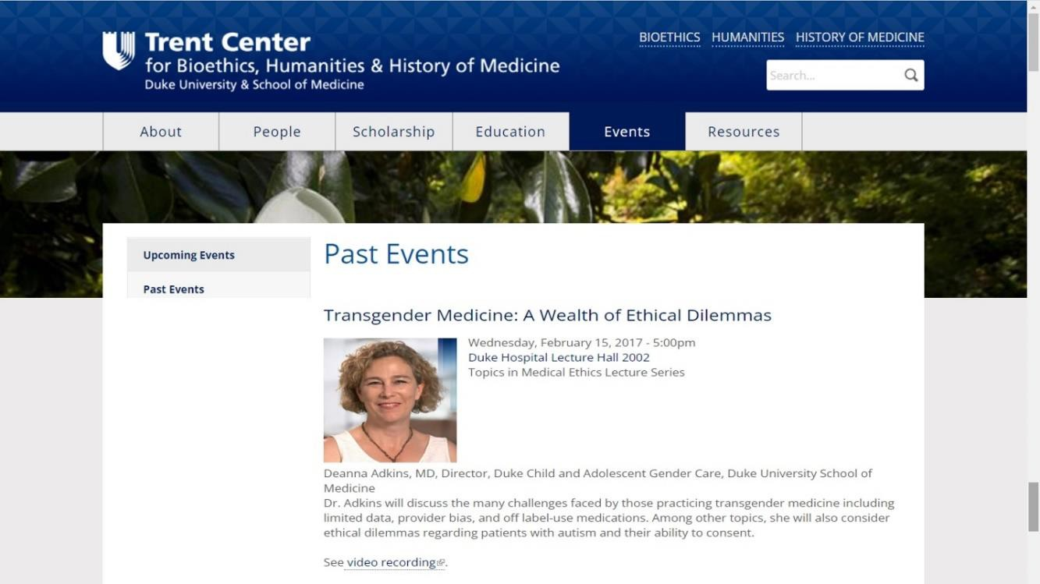

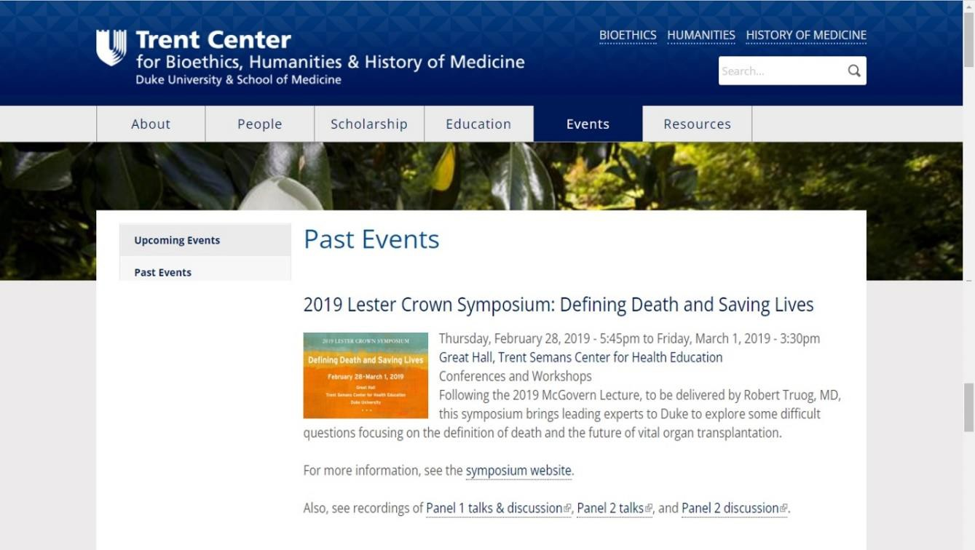

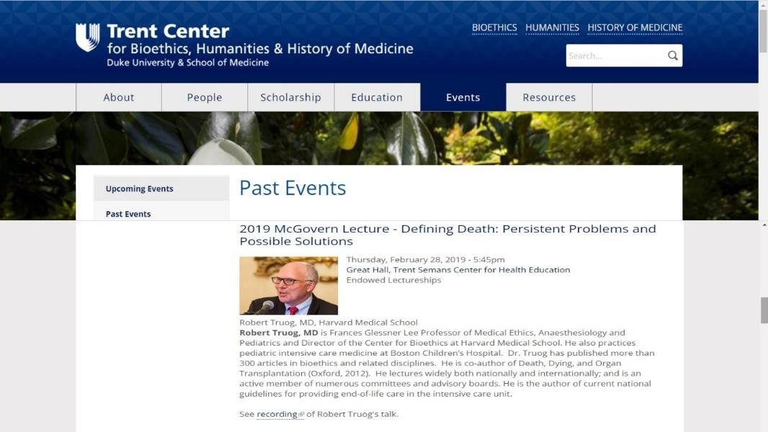

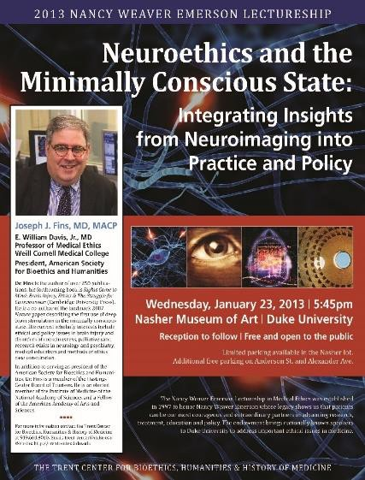

Required Academic Standards for Progression in the Program

Didactic Month:
  - Attend all lectures and grand rounds
  - Complete all assigned online LMS modules and lectures on videos,
  - Complete evaluation of outgoing residents’ final presentations,
  - Present an oral PowerPoint presentation on a topic pertaining to surgical patients.

Clinical Rotations:
1. Skill Development in Early Rotations:

- Demonstrate ability to complete and document a thorough History and Physicals, progress notes, and a thorough and complete discharge summaries by the end of the first rotation.
- On the American College of Surgeons’ Fundamental Surgery Curriculum (ACS FSC), review Module I – Patient and Workplace Safety, and Module II – Preoperative Assessment and complete the Self- Evaluation by the end first rotation (November).
2. Progressive Competency Building:
- One oral case presentation at Chairman Rounds within first 6 months and submit the write-up to the program faculty.
- Review 3 modules on ACS FSC relevant to rotations and complete the Self-Evaluation by each quarterly meeting with the Program Director and the remaining 12 modules by final evaluation.
3. Ongoing Feedback and Assessment:

- Residents are evaluated by faculty after each rotation using a 5-point Likert scale to assess patient care, medical knowledge, practice-based learning, interpersonal skills, and professionalism.
- Continued improvement in end-of-rotation evaluations without deficiencies. If any deficiencies are noted, must complete the prescribed remediation
- Quarterly meetings with the program director are used to review rotation evaluations, identify areas for improvement, and ensure progression toward learning outcomes.

Milestones for Progression in the Residency

The PA surgical resident will demonstrate progression of skills to manage multiple simultaneous patient encounters with ability to multi-task prior to rotation on nights. If a resident is unable to demonstrate this ability or patient safety concerns exist, rotation schedule will be adjusted.

The Duke PA Surgical Residency Program emphasizes a structured and measurable progression of skills to ensure residents achieve core competencies in patient care, medical knowledge, practice-based learning and improvement, interpersonal and communication skills, and professionalism. Residents are assessed regularly to ensure they meet program standards and are prepared for independent practice.

Core Milestones
1. Clinical Competency Development
• Residents will demonstrate increasing proficiency in managing multiple simultaneous patient encounters and multitasking during clinical duties.
• Prior to rotating on night shifts, residents must show consistent ability to balance clinical demands effectively while ensuring patient safety.
• If a resident does not meet these expectations or safety concerns arise, the rotation schedule will be adjusted to provide additional training and support.

2. Evaluation and Feedback Process
• Residents are evaluated by faculty after each rotation based on a 7-point Likert scale, with the minimal acceptable performance being “average.”
• Evaluations assess progress in the core competencies of:
• Patient Care: Clinical judgment, procedural skills, and patient outcomes.
• Medical Knowledge: Application of evidence-based medicine to surgical cases.
• Practice-Based Learning and Improvement: Adaptability and integration of feedback to improve performance.
• Interpersonal and Communication Skills: Effective communication with patients, families, and the healthcare team.
• Professionalism: Integrity, ethical decision-making, and respect for diversity.
- System based Practice: display awareness of and responsiveness to larger healthcare system

3. Quarterly Review Meetings
• Faculty and residents will meet quarterly to evaluate progress, address individual needs, and review performance.
Meeting content is guided by:
• Rotation Evaluations: Quantitative and qualitative feedback.
• Preceptor Feedback: Written and verbal assessments.
• Individual Resident Concerns: Self-identified areas for improvement.
• Clinical Performance and Testing: Results from laboratory, classroom, and simulation sessions.
4. Ongoing Feedback Opportunities
• Residents are encouraged to request additional feedback or meetings at any time during the program for performance reviews or to address concerns.

5. Remediation and Individualized Education Plan (IEP)
• Residents who do not meet the minimum performance standard of “average” may be required to undergo remediation.
• An Individualized Education Plan (IEP) will be implemented to address specific areas of deficiency.
• The IEP will include targeted goals, a timeline for improvement, and additional resources or support (e.g., focused rotations, simulation training, or supplemental education).
• Progress will be monitored closely, with ongoing feedback provided to ensure the resident achieves the expected level of competency.

Criteria for Successful Completion
• A “Successfully Completed” rotation reflects an “average to above average” evaluation on the 7-point Likert scale.
• This performance level is the minimum standard required for successful progression and completion of the residency program.
• Failure to meet these standards despite remediation efforts may result in further actions, including extension of the program or dismissal, as determined by the program director and faculty.

PA Surgical Residency Rotation Goals and Objectives

Goals and objectives applicable to all rotations followed by rotation specific patient care and knowledge objectives

Surgical Oncology – Blue Service Thoracic Surgery
Vascular surgery – Green Service Night Float
Acute Care Surgery /Trauma – Red Service Transplant Surgery – Purple Service Colorectal Surgery – Gold Service
Surgical Intensive Care Unit (SICU) Neurosurgery
Urology
Plastic and Reconstructive Surgery
OHNS (Otolaryngology, Head, and Neck Surgery) Pediatric Surgery
Orthopedic Surgery
General Surgery – Duke Raleigh Hospital General Surgery – Duke Regional Hospital

PA Surgical Residency Training Objectives
For All Rotations

Patient Care

- Gather thorough, yet succinct and focused history
- Perform a focused, yet through physical exam related to patient history
- Follows procedural protocols, minimizes risk and discomfort to patients
- Provides proper explanation of procedures and seeks appropriate level of supervision
- Appropriate record keeping- timely, accurate, thorough and succinct
• Operating Room:
- Sterile Technique
- Draping
- One and two-handed knots with silk
- Common instrument terminology
- Timely operative notes, procedure notes, and postoperative orders

Medical Knowledge

- Patient safety- PA understands their ability, knowledge and skill levels in relation to patient safety and communicates appropriately to senior residents and/or attendings
- General medical knowledge- understands basic concepts of patient care
- Understands principles of post operative care
- Ability to interpret laboratory studies and tailor tests to the problem at hand
- Understands and applies surgical principles to clinical problems
- Consults current surgical literature
- Reads OR cases, knows pertinent anatomy
- Integrates basic science into diagnostic plan and treatment options

Practice Based Learning and Improvement
The PA Surgical Resident should demonstrate the ability to:
- Evaluate published literature in critically acclaimed journals and texts.
- Apply clinical trials data to patient management.
- Participate in academic and clinical discussions.
- Teach medical students and physician assistant students.
- Attend conferences

Interpersonal and Communication Skills
The PA Surgical Resident should demonstrate the ability to interact with the following persons professionally:
- Patients;
- Family members;
- Nursing staff; and
- Other members of the care team.
- Attentive and contributory on rounds
- Presentation skills are concise, complete and with current patient data

Professionalism
The PA Surgical Resident should:
- Be attentive and reliable
- Be receptive to feedback on performance.
- Be attentive to ethical issues.
- Model respect and professionalism in interactions with all patients, families, and colleagues, acknowledging the impact of individual differences on the care experience
- Demonstrate leadership.
- Present self with dignity, groomed and punctual
- Enters case logs, work hours and evaluations on time
- Stays current with ACS FCS modules

Systems-Based Practice
The PA Surgical Resident should:
- Be aware of cost-effective care issues.
- Have information technology/computer resources available
- Displays awareness of and responsiveness to the larger healthcare system

PA Surgical Residency Training Objectives

Hepatobiliary Surgery- Blue

The PA Surgical Resident on the Blue/ GI Surgery Service should demonstrate the ability to:
- Evaluate pre-operative patients with complex GI issues (ex: hepatobiliary, colo-rectal, upper and lower GI).
- Manage ward/postoperative patients.
- Prioritize patient acuity.
- Manage ward emergencies (arrhythmia, hypoxia, shock, etc.).
- Prioritize clinical responsibilities.
- Plan discharge.
- Perform (or have experience with) the following ward procedures:
  - Peripheral line/Phlebotomy.
- NG tube placement and/or management.
- Dobhoff placement and/or management
- Wound Debridement.
- Colectomy.
- Ostomy care
- Lysis of adhesions.
- Cholecystectomy, laparoscopic.
- Cholecystectomy, open.
- Hernia repair.
- Incision closure.

Medical Knowledge
The PA Surgical Resident on the Blue Surgery Service should understand:
- Basic Science principles (ex: metabolism, wound healing).
- General Surgery principles (ex: acute cholecystitis).
- GI Surgery principles (ex: perforated ulcer).
- General Medicine principles (ex: infectious disease).
- Radiographic studies: indications and interpretation

PA Surgical Residency Training Objectives

Thoracic Surgery

Patient Care
The PA Surgical Resident on the Thoracic Surgery Service should demonstrate the ability to:

- Evaluate pre-operative patients with complex thoracic issues or procedures including (but not exclusive of) benign and malignant tumors of the chest, aneurysmal disease of the thoracic aorta, malignant disorders of the diaphragm/pleura/chest wall and non-neoplastic disorders of the esophagus.
- Understand the operative steps for the following procedures commonly performed on the service:
  - Pulmonary resections (wedge, lobectomy, and pneumonectomy)
- Manage ward/postoperative patients.
- Prioritize patient acuity.
- Manage ward emergencies (arrhythmia, hypoxia, shock, etc.).
- Prioritize clinical responsibilities.
- Plan discharge.
- Perform (or have experience with) the following ward procedures:
  - Peripheral line/Phlebotomy.
  - Chest tube placement and/or management
  - Wound Debridement.
  - Pacing wires

Medical Knowledge
The PA Surgical Resident on the Thoracic Surgery Service should understand:
  - Basic Science principles (ex: lung volumes, wound healing).
  - Thoracic Surgery principles (ex: pneumothorax).
  - General Medicine principles (ex: infectious disease).
  - Common presenting signs and symptoms, evaluation of, and management of the following:
    - Pulmonary malignancies (primary and metastatic)
    - Pulmonary infections (fungal, bacterial)/empyema
    - Tumors of the mediastinum, pleura, and chest wall
    - Aneurysmal disease of thoracic aorta
    - Esophageal cancer and benign tumors
    - Benign conditions of the esophagus (spasm, achalasia, diverticula)
    - Spontaneous pneumothorax
    - Benign and malignant pleural effusions
    - Post operative arrhythmia (afib, a flutter) management

Suggested Reading: In addition to sections from the major surgical textbooks relating to your individual patients, you should inquire of the faculty surgeons as to special contemporary articles and or texts that they would consider relevant.

PA Surgical Residency Training Objectives

Vascular Surgery Service - Green

Patient Care
The PA Surgical Resident on the Green–Vascular should demonstrate the ability to:
- Evaluate pre-operative patients with Peripheral vascular disease and its risk factors
(ex: CD, Smoking history, Diabetes)
- Manage ward/postoperative patients
- Prioritize patient acuity
- Manage ward emergencies (arrhythmia, hypoxia, shock, etc.)
- Prioritize clinical responsibilities
- Plan discharge
Assist/Perform (or have experience with) the following ward procedures:
- Peripheral line/Phlebotomy
- NG tube placement and/or management
- Dobhoff placement and/or management
- Wound Debridement
- Operative procedures:
  - Extremity amputations
  - Placement of long-term central venous access
  - Debridement of complex wounds

Medical Knowledge
The PA Surgical Resident on the Green-Vascular Service should understand:
  - Diagnosis of acute limb ischemia
  - Diagnosis of acute vascular emergencies (ruptured aneurysm, aortic dissection)
  - Vascular non-invasive laboratory testing
  - Vascular imaging (CTA and MRA)
  - Evaluation and treatment of venous disorders
  - Management of common medical diagnoses associated with vascular disease (CAD, DM. ESRD, COPD)

PA Surgical Residency Training Objectives

Night Float

Introduction
The system of the night float was initiated to fulfill the ACGME hours restriction mandate while reducing excessive cross-coverage and maintaining in-patient continuity. The night float PA Surgical Resident arrives at 5:30 p.m. and leaves after morning sign-out. The night float coverage extends from Sunday to Friday with Saturday to Sunday being a continuous 24 hour-off period.

Patient Care
The PA Surgical Resident on the night float should demonstrate the ability to:
- Evaluate pre-operative patients.
- Manage ward/postoperative patients.
- Prioritize patient acuity.
- Manage ward emergencies (arrhythmia, hypoxia, shock, etc.).
- Prioritize clinical responsibilities.
- Identify limitations of their experience and activate back-up systems when appropriate.
- Perform the following ward procedures:
  - Peripheral line/Phlebotomy.
  - NG tube placement and/or management
  - Chest tube placement and /or management
  - Abg/vbg interpretation

Medical Knowledge
The PA Surgical Resident should understand:
- Basic Science principles (ex: metabolism, wound healing).
- General Surgery principles (ex: acute cholecystitis).
- General Medicine principles (ex: infectious disease).
- Radiographic studies: indications and interpretation.

PA Surgical Residency Training Objectives

Acute Care Surgery/Trauma Surgery Service

Patient Care
The PA Surgical Resident should demonstrate the ability to:
- Evaluate pre-operative patients
- Manage ward/postoperative patients
- Prioritize patient acuity
- Manage ward emergencies (arrhythmia, hypoxia, shock, etc.)
- Prioritize clinical responsibilities
- Plan discharge
- Perform primary, secondary and tertiary surveys
- take care of trauma patient
- care for TBI patients
- Care for emergency general surgery patients- including appendectomy, cholecystectomy, acute abdomen
- recognize and care for patients in shock (hemorrhagic/ hypovolemic)
- Perform the following procedures
  - ABG/ VBG interpretation
  - Peripheral line/Phlebotomy
  - NG tube placement and/or management
  - Chest tube placement and/or management
  - Debridement
  - Complex Wound Care- including wvac placement and management
  - Incision closure
  - G-tube placement and/or care
  - Laceration repair, complex
  - Tracheostomy placement and/or care

Medical Knowledge
The PA Surgical Resident should understand:
  - Basic Science principles (ex: metabolism, wound healing)
  - General Medicine principles (ex: ESRD, dialysis)
  - General Surgery principles
    - Trauma guidelines
    - Primary, secondary, and tertiary surveys
    - Shock- hypovolemic, hemorrhagic
    - Penetrating trauma
    - Blunt trauma
    - TBI management
    - Acute abdomen
    - Appendicitis
    - Acute cholecystitis
  - Radiographic studies: indications and interpretation

PA Surgical Residency Training Objectives

Transplant Surgery Service – Purple

Patient Care
The PA Surgical Resident should demonstrate the ability to:
- Evaluate pre-operative patients being evaluated for transplant
- Manage ward/postoperative patients- including DDKT, OLT, living related liver transplants, living related or unrelated kidney transplants, pancreas transplant
- Help to manage and recognize side effects of immunotherapy
- Prioritize patient acuity
- Manage ward emergencies (oliguria, arrhythmia, hypoxia, shock, etc.)
- Prioritize clinical responsibilities
- Plan discharge
- Perform the following procedures
  - NG tube placement and/or management
  - Foley catheter placement and/ or management in kidney transplant patients
  - Complex Wound Care- including wvac
  - Incision closure
  - Drain removal

Medical Knowledge
The PA Surgical Resident should understand:
  - Basic Science principles (ex: metabolism, wound healing)
  - General Medicine principles (ex: ESRD, dialysis)
  - General Surgery principles related to transplant surgery
    - Kidney transplant
    - Liver transplant
    - Pancreas transplant
    - Multivisceral transplant
    - Immunotherapy management and side effects
  - Radiographic studies: indications and interpretation

PA Surgical Residency Training Objectives

Colorectal Surgery Service - Gold

Patient Care
The PA Surgical Resident on the Service should demonstrate the ability to:
- Evaluate pre-operative patients with complex colorectal issues (ex: colon cancer, rectal cancer, and diverticulitis).
- Manage ward/postoperative patients, including but not limited to:
  - Colectomy.
  - Lysis of adhesions.
  - Common Ano-rectal procedures (i.e. hemorrhoid banding, repair fistula).
  - Cholecystectomy, laparoscopic.
  - Cholecystectomy, open.
  - Hernia repair.
  - Incision closure.
  - Laceration repair, complex
- Prioritize patient acuity.
- Manage ward emergencies (arrhythmia, hypoxia, shock, etc.).
- Prioritize clinical responsibilities.
- Plan discharge.
- Perform (or have experience with) the following ward procedures:
  - NG tube placement and/or management
  - Dobhoff placement and / or management
  - Wound Debridement/ care, including wvac

Medical Knowledge
The PA Surgical Resident should understand:
- Basic Science principles (ex: metabolism, wound healing).
- General Surgery principles (ex: acute cholecystitis).
- GI Surgery principles (ex: diverticulitis, colon cancer).
- General Medicine principles (ex: infectious disease).
- Radiographic studies: indications and interpretation.

PA Surgical Residency Training Objectives

SICU

Patient Care:
The PA Resident on the Duke SICU Service should demonstrate the ability to:
- Organize patient data by systems
- Develop complex differential diagnoses
- Formulate comprehensive assessment and plan
- Prioritize patient acuity and tasks
- Manage ICU Emergencies (ex: arrhythmia, hypotension, hemorrhage, codes)
- Prioritize clinical responsibilities
- Participate in end of life discusions
- Plan discharge/transfer
- Perform or assist with the following procedures
  - Arterial lines
  - Bronchoscopy
  - Chest tube placement
  - Dobhoff placement
  - Endoscopy
  - Femoral line
  - Internal jugular line
  - Subclavian line
  - Tracheostomy exchange

Medical Knowledge
The PA Resident on the Duke SICU Service should understand:
- Basic Science principles (ex: metabolism, wound healing)
- Trauma Surgery principles (ex: ATLS, shock)
- General Surgery principles (ex: acute abdomen)
- General Medicine principles (ex: infectious disease)
- Critical Care subjects (ex: ARDS, SIRS, acid/base)
- Pharmacologic principles (ex: antibiotic management)
- Radiographic studies: indications and interpretation

Physician Assistant Resident Training Objectives

Neurosurgery Service

Patient Care:
The PA Resident on the Neurosurgery Service should demonstrate the ability to:
- Evaluate pre-operative patients
- Manage ward/postoperative patients
- Prioritize patient acuity
- Manage ward emergencies (ex: hypernatremia, hyponatremia, hydrocephalus, etc.)
- Prioritize clinical responsibilities
- Plan discharge
- Perform the following procedures
  - ABG interpretation
  - Peripheral line/Phlebotomy
  - Post-op drain care
  - Lumbar drain management
  - External Ventricular Drain management
  - Burr hole placement, assist
  - Halo placement, assist
  - Lumbar spinal tap/drain, assist/perform
  - Shunt flow study, assist/perform
  - VP shunt/LP shunt valve reprogramming assist/perform

Medical Knowledge
The PA Resident in the Neurosurgery Service should understand:
- Basic Science principles (ex: electrolyte imbalances)
- General Medicine principles (ex: diabetes insipidus)
- Neurosurgery principles (ex: ICP, peripheral and central nervous systems examination)
- Trauma principles (ex: GCS Assessment, head injury)
- Pharmacologic principles (ex: narcotic management, ICP treatment)
- Radiographic studies: indications and interpretation

Physician Assistant Resident Training Objectives

Pediatric Surgery

Patient Care
PA surgical residents on the pediatric surgery service should demonstrate the ability to:
- Manage the fluid, electrolytes, and nutritional aspects of the newborn and pediatric patient.
- Initiate the evaluation and management of the bluntly injured pediatric patient.
- Initiate the evaluation of neonatal patients with common surgical diseases including inguinal hernia, necrotizing enterocolitis, esophageal atresia, intestinal atresia, abdominal wall defects, gastro-esophageal reflux, anorectal anomalies, Hirschsprung’s disease.
- Evaluate and manage the fluid and electrolyte status of children in the perioperative period.
- Perform the following procedures:
- Place a central venous indwelling catheter in the subclavian vein.
- Remove an indwelling central venous catheter.
- Assist in the repair of an inguinal hernia in a school-aged child.
- Close an abdominal incision in a school-aged child.
- Appendectomy, assist.

Medical knowledge
PA surgical residents in the pediatric surgery service should understand:
- The nutritional, fluid, and electrolyte requirements of children
- The pathophysiology, method of evaluation, and management of common pediatric surgical diseases including pyloric stenosis, intestinal malrotation, intestinal atresia, esophageal atresia, abdominal wall defects, anorectal anomalies, congenital lung anomalies, thyroglossal duct cyst, Hirschsprung’s disease.
- The indications and contra-indications for the placement of central venous lines

PA Surgical Training Objectives

Duke Raleigh Hospital Surgery Service

Patient Care
The PA Surgical Resident on the Duke Raleigh Surgery Service should gain experience with and demonstrate the ability to:
- Evaluate pre-operative patients
- Manage general surgery ward/postoperative patients
- Manage ER/Trauma patients
- Assess surgical consult patients
- Prioritize patient acuity
- Manage ward emergencies (arrhythmia, hypoxia, myocardial infarct, shock, etc.)
- Prioritize clinical responsibilities
- Plan discharge
- Assist in the following procedures
- IV placement/Phlebotomy
- NG tube placement
- Amputation (AKA, BKA)
- Appendectomy
- Breast: sentinel LND Breast: lumpectomy
- Breast: mastectomy
- Cholecystectomy, laparoscopic
- Cholecystectomy, open
- Hemorrhoidectomy
- Hernia repair, inguinal
- Hernia repair, ventral
- Hickman catheter
- Laceration repair, complex
- Open/close laparotomy
- PEG
- Tracheostomy
- Wide local excision

Medical Knowledge
The PA Surgical Resident should understand:
- Basic Science principles (ex: metabolism, wound healing)
- General Surgery principles (ex: acute abdomen)
- Critical Care subjects (ex: ARDS, SIRS, MODS)
- General Medicine principles (ex: infectious disease)
- Pharmacologic principles (ex: antibiotic management)
- Radiographic studies: indications and interpretation

Practice-Based Learning and Improvement
The PA Surgical Resident on the Service should demonstrate the ability to:
- Evaluate published literature in critically acclaimed journals and texts
- Apply clinical trials data to patient management
- Participate in academic and clinical discussions
- Teach medical students and physician assistant students
- Attend conferences

Interpersonal and Communication Skills
The PA Surgical Resident should demonstrate the ability to:
- Interact with Patient/Family
- Interact with nursing staff
- Interact with Patient Resource Manager and Social Workers
- Interact with OR staff
- Interact with Consult Service
- Interact with Attendings
- Interact with Junior House staff
- Interact with Senior House staff

Professionalism
The PA Surgical Resident should:
- Be receptive to feedback on performance
- Be attentive to ethical issues
- Be involved in end-of-life discussions and decisions
- Be sensitive to gender, age, race, and cultural issues
- Demonstrate leadership

Systems Based Practice
The PA resident should:
- Be aware of cost-effective care issues
- Be sensitive to medical-legal issues
- Information technology/computer resources available

PA Surgical Residency Training Objectives

Duke Regional Hospital Surgery Service

Patient Care
The PA Surgical Resident on the Duke Regional Surgery Service should gain experience with and demonstrate the ability to:
- Evaluate pre-operative patients
- Manage general surgery ward/postoperative patients
- Manage ER/Trauma patients
- Assess surgical consult patients
- Prioritize patient acuity
- Manage ward emergencies (arrhythmia, hypoxia, myocardial infarct, shock, etc.)
- Prioritize clinical responsibilities
- Plan discharge
- Assist in the following procedures NG tube placement
- Amputation (AKA, BKA)
- AV Fistula
- Appendectomy
- Breast: sentinel LND Breast: lumpectomy
- Breast: mastectomy
- Cholecystectomy, laparoscopic
- Cholecystectomy, open
- Endoscopy
- Hemorrhoidectomy
- Hernia repair, inguinal
- Hernia repair, ventral
- Hickman catheter
- Laceration repair, complex
- Open/close laparotomy
- PEG
- Tracheostomy
- Wide local excision

Medical Knowledge
The PA Surgical Resident should understand:
- Basic Science principles (ex: metabolism, wound healing)
- General Surgery principles (ex: acute abdomen)
- Critical Care subjects (ex: ARDS, SIRS, MODS)
- General Medicine principles (ex: infectious disease)
- Pharmacologic principles (ex: antibiotic management)
- Radiographic studies: indications and interpretation

Practice-Based Learning and Improvement
The PA Surgical Resident on the Service should demonstrate the ability to:
- Evaluate published literature in critically acclaimed journals and texts
- Apply clinical trials data to patient management
- Participate in academic and clinical discussions
- Teach medical students and physician assistant students
- Attend conferences

Interpersonal and Communication Skills
The PA Surgical Resident should demonstrate the ability to:
- Interact with Patient/Family
- Interact with nursing staff
- Interact with Patient Resource Manager and Social Workers
- Interact with OR staff
- Interact with Consult Service
- Interact with Attendings
- Interact with Junior House staff
- Interact with Senior House staff

Professionalism
The PA Surgical Resident should:
- Be receptive to feedback on performance
- Be attentive to ethical issues
- Be involved in end-of-life discussions and decisions
- Be sensitive to gender, age, race, and cultural issues
- Demonstrate leadership

Systems-Based Practice
The PA Surgical Resident should have:
- Be aware of cost-effective care issues
- Be sensitive to medical-legal issues
- Information technology/computer resources available

Outline of Your Average Day

0530 or 0430 (Wed):
Sign out - sign on to functional pager (dial 970-functional pager, press *#, the password will always be the last 4 digits of the functional pager number and #, press 151, then enter your pager number) 0600 or 0500 (Wed):

Morning Report on 2200 (only for Duke GSU rotations)
0600 – 0700:

Resident rounds
0700 - 0800
Place orders and write notes in EPIC

Strategy for order priority:
- Tests that need to be completed (i.e., radiology, ECHO, etc.)
- Diet orders
- Discharges
- All other orders (i.e., electrolyte supplements, daily labs)

0800:
Call Consults
Communicate with the nurses about the plan for day Talk to the patients and review discharge information

0830-0900:
Run the list with the case manager (CM)- they need to know about needs for home wound vac, wound care, IV antibiotics, home PICC, home PT/OT (recommendations from therapy notes), home oxygen

0930-1730:
Pull drains, chest tubes, staples; change wound vacs; f/up on am orders Round as often as possible throughout the day (between cases, clinic, etc.) 17301800:
Round or at least run the list with the chief before leaving EVERY DAY If they are in the OR, go to the OR and Update the list

1800-1830:
Sign-out to night team (only after signing out / rounding with the chief)

Presentations
- Confidence
- Eye contact
- Never lie – saying “I don’t know but I will find out” is OK
- Be a team player – there is no such thing as scut work
- You are the provider – if something needs to be done, you must make it happen

Miscellaneous
  - All procedures (chest tube pull, wire pulls, jp pulls, placing stitches, dressing changes) – at the beginning of the day so if problems, there is help around
  - Post pull films if indicated (i.e. chest tube pull, ngt placement, etc.)
  - Review with radiologist films (call or go downstairs if needed) – find numbers on http://www.dukerad.radsq.com/index.php?title=Main_Page
  - Always look at an x-ray/CT scan yourself (this is how you learn)

Unit Phone numbers
  - Duke North: 681-first two digits of unit 41 (i.e., 2100 HUC – 681-2141)
  - Duke Medicine Pavilion: 385-6941 for 6W SICU

Supplies – Pyxis on every unit, Charge nurse can grant access and help you create an account

Calling Consults
You are calling a colleague for help caring for a patient. Be professional. Know the patient – always give name, MRN, room #, and story put the order in through EPIC. DO NOT TEXT PAGE consults.

Paging Etiquette
  - Always leave your name, call back number, and your pager number (ex: Cecilia Ong 681- 2224*9525)
  - Do not just leave your name or pager number

Intern Sign-Out
Mr./Ms. in room is a y.o. M/F with a PMH notable for who is stable/sick now POD s/p
[procedure] for [diagnosis/pathology/injuries]. His/her hospital course has been
uncomplicated/notable for . Over the last 24 hours, he/she has had the following events:”
- Clinical events /changes in status

- Procedures
- Consults
- Pertinent imaging, labs, micro 5. Relevant medications include.
The major complication we are worried about tonight is , and our plans are if this happens.
We are currently awaiting [consult input, imaging study, test results].
When the results of are completed, [let service\in-house chief\consult service know, start/stop (medication).
The receiving resident then repeats his/her understanding of action items: Examples:
- Patient is stable with nothing pending.
- Patient is sick and has a CT pending. If it shows an abscess, we will make him/her NPO and plan for a drain tomorrow.
- Patient is stable, but the creatinine has bumped. We are awaiting recommendations from nephrology, and I will contact the night chief regarding the recs. Time for questions/confirmation

Admissions
  - Nurse or HUC should page you when patient arrives- don't rely on this though, if you know they are coming, keep an eye on them
  - You do not always know in advance (aka if they are a direct admit from the clinic) – go see the patient immediately
  - If admitted from ED, they should have an H&P and orders from ED GSU consult resident o If admitted from ED, you MUST manually end the previous first call before assigning yourself as first call or it will not work
  - 2222/7704 will touch base when they have time
  - Direct admits o H&P (can steal a template) o Basic Orders – including pain, nausea,
DVT PPx (if no procedure pending), NPO, IVF, home medications as appropriate
    - Basic labs – order or if sick, draw yourself
      - When in doubt, get pre-op labs (CBC, BMP, Mg, type and screen, PTT, INR),
LFTs, Amylase/Lipase if liver or pancreas patient
      - Nutrition labs (albumin, prealbumin, transferrin) if cancer patient or nutritionally depleted
      - Check UA/Cx, blood cx x 2, and PA/Lat CXR on all pts with concern for infection
      - Consider PA/Lat CXR and EKG on most patients o OSH images

      - Take to radiology file room in first floor and have it loaded on PACS
      - In epic, order “request to upload outside images” and request to read outside images so Duke radiology reads it (if needed)
      - If no tangible disk, check power share on EPIC. Can call OSH to push files over.
    - Make sure the appropriate senior resident is aware that patient has been admitted and sees patient
    - If night admission, let primary resident know if early

Basic orders for every patient:
Diet
  - If NPO, need IVF with half insulin or insulin sliding scale if on PO diabetic meds
  - No concentrated sweet diet if diabetic, renal diet if ESRD/CKD If NG tube – convert po meds to IV
If gastric or esophageal surgery – absolutely nothing by mouth including meds, until specified
by attending

IVF

- NS and LR for initial resuscitation
- Usually house wine (D5 1/2NS with 20meq KCl) if out of resuscitation phase
- All pts who are NPO need dextrose in IVF to prevent ketosis
If dialysis only ~30ml/hr D5NS if NPO, no K in fluid if renal dysfunction (or NO FLUIDS AT ALL)
- If CAD, look for prior Echo to evaluate for EF, lower IVF, start on telemetry
- Labs – usually CBC, BMP, Mg, LFT if liver resection or gallbladder
- Not every pt needs these labs every day, chief will specify, attending specific

DVT ppx
  - Heparin 5000 Units SQ q8h (cannot if h/o HIT), Neurosurgery Cranial 5000 Units SQ q12h
  - Lovenox 40mg daily (cannot if has epidural, Lumbar Drain, EVD, HD, or CKD)
  - Sequential compression devices (do not if hx of lower extremity PAD or DVT)

Pain medication – multimodal
  - Tylenol (1g Q6h or 650 q6h if liver dz), oxycodone, breakthrough IV pain meds when appropriate
  - Gabapentin +/- NSAID (naproxen, Toradol) when appropriate, ask chief

  - Can consult inpatient Acute Pain Service (APS) for intractable pain, addicts, etc. (Check with chiefs or attending if okay). They are automatically consulted for patients with an epidural catheter.
  - Lidocaine patches are helpful for chest tube/jp-related pain

Nausea meds PRN (Ondansetron 4mg IV q6hPRN- unless prolonged QT, Phenergan 6.25mg IV q6hPRN- unless elderly)

Activity
  - OOB everyday (unless otherwise told) – order in Epic
  - OOB to chair, OOB ambulating tid
  - Consult PT/OT if needed
  - Incentive spirometer for everyone, also needs an order in Epic; follow-up that they actually use

Basic Considerations for Chronic Patients
  - PT/OT consults early (before 7am for them to be seen that day; need to reorder after OR ICU)
  - Daily weights Nutrition/tube feed recs
  - Nutrition labs every Monday (albumin, prealbumin, transferrin)
  - Case management – placement – keep chief up to date about plans o Let CM know about wound vac, wound care, IV abx, home PICC ASAP o Need specific note
/measurements for wound vac; CM should fill out a form, attending signs
  - Follow up daily with consultants

Pre-op Patients
  - Labs depend, but usually – CBC, BMP, PTT/INR, T&S or T&C, UA, UCx , EKG, CXR if necessary
  - Skull x-ray and Brainlab (neurosurgery)
  - COVID-19 test
  - Consent – make sure you know surgery and risks, No abbreviations
  - Use case posting for correct surgery and attending, use correct medical terminology • Mark correct side- can use sterile markers found in pyxis or Sharpie
  - Post with correct leveling (“case request operating room” order, call OR front desk at 6812255)

  - NPO after midnight with IVF
  - hold anticoagulation, tube feeds,

OR
  - Get there before attending
  - Introduce yourself to circulator and scrub, write name on board.
  - Pull gloves/gown
  - Pull up images on computer
  - Shave, foley, position, prep
  - Lap choles- arms out, no foley
  - Lap appys- left arm tucked, foley
  - Fix monitors if case is laparoscopic
  - Discuss with attg who is doing orders/op note
  - When done, escort pt to PACU, write orders, brief-op note (before leaving OR), update service’s intern, dictate
  - Write contact info on post-op handoff white board, +/- labs/imaging/diet needed
  - Discharge from PACU: write orders, write notes, give discharge instructions, rx, f/up appt

Discharges
  - Discuss with case managers and chief
  - “Patient Instructions” tab is blank area for free text or search for a template (.gsudcinstructions)
  - Scripts (print at HUC where pt is located or e-Prescription to their pharmacy of choice) Colace or Senokot-S if on pain meds, not needed in patients with ileostomies All narcotic scripts have to be printed and signed or electronically authorized
  - Typing “Blank” in new orders and selecting free text will give you a blank script form
  - Use “SUR General Surgery Discharge” order set whenever possible with common instructions
  - Make all follow-up appointments yourself through clinic assistants – put on paperwork
  - Pt is to call attending’s clinic during day (put this number on the paperwork) and 684- 8111 in evening
  - Never give out pager numbers or cell phone numbers
  - Have all instructions and Rx’s done on Friday for expected/possible weekend discharges, you may have to write d/c sums for patients who are discharged over the weekend even if you are not on that day

If there is a patient with a complex inpatient history of long LOS, it is a good idea to get a head start on the dc summary, ESPECIALLY if they are discharging to an LTAC or SNF because the dc summary must be completed AT THE TIME OF DISCHARGE

Wound care – wound vac, dressing changes, take a picture for the chart/chief

Wound Vacs
  - The wound vac consists of the black vac sponge, vac drape (sheets of clear plastic adhesive), and the tubing/ canister – supplies in pyxis
  - For new vacs, you have to order the pump through Epic; it gets delivered to the HUC of the unit where the patient is located (takes ~45 min). Call them to expedite.
  - To change the vac:
    - Premedicate with pain meds, assemble new foam/tape/tubing/device/canister/scissors
    - Take vac off suction, remove tape and foam. Saline flushes or adhesive remover help.
    - Cut new foam to the size of the wound (make sure it is only covering the wound and NOT healthy skin because it will become macerated, can put down vac drape to protect skin)
    - Cover the foam with vac tape (give yourself a healthy margin - at least a few inches), cut a 1cm circle in the tape over the foam in a dependent area
    - Place the adhesive circle with the tubing attached over the circle in a comfortable place for the tube to hang off the patient (i.e., not down the center in front of genitals)
Hook up the tubing to the device = 'moment of truth' to see if the system works - you should see the foam suction down almost immediately. If that does not happen, you can hook the tubing up to wall suction to make sure that the problem is not with the device/canister. More likely, there is a leak somewhere and you can reinforce the vac tape either with more sheets or just tegaderm if it is a small area. o If there are skin folds, stoma paste is helpful to fill them in.
    - IF YOU ARE WORRIED ABOUT A FASCIAL DEHISCENCE OR SEE BOWEL, DO NOT PUT THE VAC ON
  - On nights, you usually will not have to do routine wound vac changes. More commonly you will be called to troubleshoot wound vacs that are not holding suction. Most of the time, you can get away with reinforcing the edges with a bunch of tegaderm without actually changing the vac. Some patients come out of the OR with PICO devices in their

midline abdominal incisions, which are basically incisional wound VACs. The nurses will page you if they beep - usually the problem is with the device rather than the dressing. Make sure the canister is seated in the unit securely.

NG Tubes
  - Supplies: NG tube (16 or 18 French, a little stiffer, and will not get clogged as easy), canister, suction tubing, wall suction regulator, barf basin, lube, hurricane spray/urojet/ lidocaine swish and swallow, tape to secure tube, cup with water and straw
Counsel the patient on what the tube is, how it works, symptom relief, tube stays in for a few days
  - Set up your suction tubing and make sure it works, prep length of tape to secure the tube
  - Spray the throat with hurricane spray, can also use lidocaine jelly (aka urojet) for nostrils
  - Look in their nose for deviated septum, make a guess at which side is bigger – ask which they breathe better out of
  - Have the bed sit all the way up (90 degrees), instruct pt to look down with chin touching sternum for good angle
  - Measure length of tube (nare to carina – 55cm is usually ok), curl tube around your fingers so it has an actual curve that you can direct, this really makes a difference so take time to do it
  - Instruct the patient “I’m going to place the tube in your nose. I’m going to ask you to
swallow when instructed to help the tube go down” sometimes water helps this so have a cup handy with straw for a nurse to hold for the patient, a lot of patients vomit so make sure to have the bucket
  - Lube NGT and place in chosen nostril, gently pass tube straight back (not angled superiorly!) until you reach the back of nasopharynx, you may feel mild resistance (not a lot!) its ok to push past gently to make the curve then ask them to start swallowing, with water if necessary
  - Again, insert the tube PARALLEL TO THE FLOOR, do not point up
  - When tube is in desired depth ask if they are okay (when they phonate normally you know it is not in the trachea), have them open their mouth to make sure it is not coiled in their mouth
  - Attach to suction and set, note how much initially came out
  - Put NGT settings in Maestro (wall suction – ILWS, flushes, PPI/H2 blocker IV, NPO, convert PO meds to IV), Xray for positioning
  - If fresh esophageal or gastric anastomosis, check with senior before placing tube (as you do not want to blow through the new anastomosis); IR can place tubes if high-risk

